n

Information for Non-IAG Qualified Staff
Providing Information, Advice and Guidance (IAG) and Careers Education Guidance (CEG) – 2020/21

It is an essential requirement that Information, Advice and Guidance (including Careers Education Guidance) is thoroughly embedded into all course delivery in order to ensure that learners are fully informed about the options available to them, and the support they can access to help them progress towards their career/learning aims. Learners should be encouraged to take responsibility for their action points wherever possible.

Tutors should ensure that they are aware of the appropriate next steps available to their learners to enable them to progress in their chosen area. For example, if a learner is on a basic IT course and they would like to further develop their newly acquired skills, what would be an appropriate course for them to progress onto? How can they obtain further information about the course?

The following information is intended as a guide for non-IAG qualified staff to assist them in delivering IAG to their service users. This list is not exhaustive, and other organisations not mentioned here may provide a more appropriate service for some learners.

- What is IAG? IAG stands for Information, Advice and Guidance.

Career/Learning based IAG offers:

- help with identifying training programmes or learning opportunities
- support with job hunting
- assistance with overcoming barriers to learning/work, such as childcare, time or financial concerns
- CV advice and/or support
- interview/cover letter hints and tips
- relevant signposting (recognising when someone should be referred elsewhere)
- free, CONFIDENTIAL and impartial support
- assistance with creating SMART goals – Specific, Measurable, Achievable, Realistic, Timely

- Why do we offer IAG?

IAG is provided to help people to make informed choices about their own future. It can:

- provide an opportunity for people to learn more about the services available to them
- enable people to progress within learning or work
- assist people in achieving their aims
- increase confidence and awareness
- help improve communities life, e.g. parent feels more confident with maths and can in turn pass this within the family
- Who is entitled to IAG?
CW&C’s Skills and Employment Team is committed to providing IAG to all service users that request it.
Service users include:

- people on learning courses provided by CW&C Skills and Employment Team and partner organisations
- individuals receiving support from the Skills and Employment Team, but who may not be currently attending a course, e.g. receiving support from an employment mentor
- general members of the public requesting support through, for example, email, letter or telephone

- What are barriers to progression, and how can we help people overcome them?

There are many reasons why people may find returning to employment or accessing learning difficult. The role of the IAG Advisor is to help the person to overcome such barriers.

Examples of barriers into employment and/or learning could include:

- lack of childcare – contact CW&C Information, Advice and Support Service (see 5.8)
- financial concerns – free courses, funded support (e.g. if on means tested benefits), provide funding links
- past experiences, e.g. negative school experiences – discuss how learning has changed, it’s not always necessary to go to college, community/home learning etc.
- low confidence levels/nerves – confidence courses, start small, e.g. taster courses, offer personal support (if possible attend 1st session, or go with client to enrol at college for example)
- lack of transport – some colleges offer transport, identify courses closer to home, e.g. in community/learning centres
- language – ESOL courses and support groups (e.g. CHAWREC)
- age – learning is for all ages, specific courses for older members of the public etc.
- not knowing where to start – offer brokerage service to help identify where/when etc.
- poor literacy/numeracy skills – explain support available, literacy and numeracy courses in the community etc.
- disabilities – explain accessibility and support on offer, specific organisations offering support to people with disabilities

- Where could we signpost to?

The following information provides a general overview of just some of the support that may be available to learners:

5.1 National Careers Service

Learners requiring free, impartial careers advice and support can be referred to the National Careers Service website - https://nationalcareersservice.direct.gov.uk where they will have access to a range of resources designed to assist them with their career development. They will also have the opportunity to speak to a National Careers Advisor online to receive personalised support.

To speak to an advisor over the telephone, learners can call 0800 100900.The service is also available as an app on ios and Android devises.

Arrangements can also be made for an NCS Advisor to visit your Group during the course, and for learners to receive an individual, face to face, appointment should they want one.

To arrange for your learners to meet with an NCS advisor, please contact:

Clare Bruder - National Careers Service Team Leader for Cheshire, Warrington and Merseyside. Email Clare.Bruder@careerconnect.org.uK

5.2 Specialist Services – including Safeguarding

Where specialist support is required, learners should be signposted accordingly. Advisors should never advise on areas that they are not knowledgeable about, or qualified in.

Some examples of agencies learners may need specialist support from include:

Cheshire West and Chester Integrated Access Team - Telephone 0300 1237034 or the Emergency Out of Hours Team on 01244 977277 if out of hours.

Citizen’s Advice Bureau (CAB) - https://www.citizensadvice.org.uk/

Housing (Cheshire West) - http://www.cheshirewestandchester.gov.uk/residents/housing.aspx

For Government Services and Information - www.gov.uk

5.3 Colleges and Community Learning Centres

For information about locally accessed Further Education can be found on the Cheshire West and Chester website

For Colleges, Universities and information on support services for students, visit: http://www.cheshirewestandchester.gov.uk/residents/education-and-learning/further-and-higher-education.aspx

For links to local organisations offering adult learning opportunities, visit: http://www.cheshirewestandchester.gov.uk/residents/education-and-learning/further-and-higher-education/skills-and-employment/adult-learning.aspx

5.4 Community Learning in Cheshire Course Portal

Tutors can access the CL in Cheshire Course Portal at https://cheshireadultlearning.org/courses to view a list of adult learning courses available local to them.

5.5 Volunteering Opportunities

Some learners may express an interest to become involved in voluntary work. Tutors can refer learners to the following webpages https://www.gov.uk/government/get-involved/take-part/volunteer. Learners will be able to access a nationwide database of volunteering opportunities in a range of occupational areas, and can filter the results to provide a list of vacancies available within a chosen radius to their home.

5.6 Cheshire West and Chester Work Zones

Work Zones are based in Chester, Ellesmere Port, Winsford and Northwich. They offer a range of free services to support people aged over 19 with their job hunting and employability skills. As well as having free access to computers for job searching and applications, those registereing with the Work Zones will also have the opportunity to work with an Employment Mentor who can support them on a one to one based in their search for work.

For further information visit the Work Zone pages of the Cheshire West and Chester website at www.cheshirewestandchester.gov.uk/residents/education-and-learning/further-and-higher-education/skills-and-employment/work-zones.aspx or call Alison Reid on 01606 288908.

5.7 Skills for Families, Life and Work

Family Learning aims to help parents/carers become more confident in supporting their child’s learning, but also looks at enhancing the learner’s own skills to prepare them for a return to work once they feel ready. Courses run in many schools and children’s centres and focus on making the learning journey fun for both the adult and the child.

Further information can be found on the Cheshire West and Chester website at https://www.cheshirewestandchester.gov.uk/residents/education-and-learning/further-and-higher-education/skills-and-employment/skills-for-families-life-work.aspx or email Bethan Colburn at bethan.colburn@cheshirewestandchester.gov.uk

5.8 Local Offer – CWaC Information, Advice and Support Service

The Information, Advice and Support helps parents and carers, children and young people who have difficulties with learning, and or a disability from birth to 25 years. They offer help and support with such things as:

- Childcare and options available  - Benefits and grants  - Parenting support | - IAG regarding family matters, including legal  - Training information for childminders

Further information can be found on the Cheshire West and Chester website at: https://www.cheshirewestandchester.gov.uk/residents/education-and-learning/early-years-and-childcare/information-advice-and-suppor/information-advice-and-support-service.aspx , or by telephoning 0300 123 7001.

5.9 Funding to Support Learning

Some learners may be entitled to receive financial support to help fund their learning. Entitlement depends upon individual learner circumstances and therefore learners should speak to the learning provider, or be referred to the Government website for further information.
https://www.gov.uk/grant-bursary-adult-learners

  - Recruitment agencies

The National Careers Service website has an informative section on choosing recruitment agencies under ‘Careers Advice’. Learners could also speak to their local Job Centre or Work Zone to obtain the contact details of any agencies serving the local area.

It should be noted that some recruitment agencies will also offer training for the roles they are recruiting for.

- How is information recorded and stored?

Information obtained during IAG sessions is private, and therefore should be treated as such under the Data Protection Act 2018, UKs implementation of the General Data Protection Regulation (GDPR) – see https://www.gov.uk/data-protection/the-data-protection-act for further information about the Data Protection Act and GDPR.

Advisors should:

- ensure confidentiality is maintained (NB: please be aware of exceptions to the need for confidentiality should a disclosure be made)
- use safe and secure storage facilities – locked cabinet and file
- beware of memory sticks, laptops and computers accessed by others
- understand that information people give is private and should not be shared without the service user’s specific written permission. On occasions, advisors may need to share information with training providers, for example, but be prepared to keep enquiries anonymous if you do not have permission to share
- explain to the service user who may see the information (e.g. team members responsible for filing, inputting information onto the system etc.)
- ensure that people receive a copy of any information that is kept about them, or that they know they have access to it

- How to keep track of learner’s progression

Those providing IAG may be required to keep track of learners progression in order to feed back on destination.

Remember to:

- contact people on a regular basis to check on progression and to see if further support is required
- Request feedback – can the service be improved, was it useful?

- Code of Ethics

All staff members are required to be just and fair to all, to respect human rights and dignity and to adhere to legal requirements and obligations. All staff members are required to uphold the highest standards of professional behaviour as set out in the principles below.

Code of Ethics for non-teaching Staff

This Code of Ethics covers the professional behaviour and practice required for non-IAG qualified, non-teaching staff within CW&C’s Skills and Employment Team and informs the public of the ethical principles to which we adhere.

- Accessibility

Staff members must promote access to career development activities and services in a range of ways that are appropriate and ensure inclusion.

- Accountability

Staff members are accountable for their career development activities and services and must submit themselves to whatever scrutiny is appropriate to their role, including the Discipline and Complaints Procedure.

Staff members must act in the interest of society and at all times exercise integrity, honesty and diligence.

Staff members must in all circumstances endeavour to enhance the standing and good name of Cheshire West and Chester Council’s Skills and Employment Team.

- Autonomy

Staff members must encourage individual autonomy in making decisions and always act in the individual’s best interests.

- Competence

Staff members must monitor and maintain their fitness to practice at a level that enables them to provide an effective service.

Staff members must represent their professional competencies, training and experience accurately and function within the boundaries of their training and experience.

- Confidentiality

Staff members must respect the privacy of individuals. Personal guidance interactions/interviews should be conducted in an agreed and suitably private environment.

Clients must be informed of the limits of confidentiality and data sharing at the outset.

Disclosure of confidential information should only be made with informed consent or when required by law.

- Continuous Professional Development

Staff members must maintain their professional competence, knowledge and skills through participation in continuous professional development informed by reflective practice.

- Duty of Care – to Clients, Colleagues, Organisations and Self

Staff members have a duty of care and are expected always to act in the best interests of their clients.

Staff members must develop and maintain professional and supportive working relationships with colleagues both inside CW&C Council and from external organisations, and respect the contributions of career development professionals to the activities and services on offer.

Staff members must fulfil their obligations and duties to their employer (where applicable), except where to do so would compromise the best interests of clients.

Staff members have a duty of care to themselves, both in terms of their personal integrity, personal safety and their capacity to practice in order to provide an effective service to clients.
Equality

Staff members must actively promote equality and diversity and work towards the removal of barriers to personal achievement resulting from prejudice, stereotyping and discrimination.
Impartiality

Staff members must ensure that professional judgement is objective and takes precedence over any external pressures or factors that may compromise the impartiality of career development activities and services. In doing so, staff members must ensure that advice is based solely on the best interests of and potential benefits to the client.

Where impartiality is not possible this must be declared to the client at the outset.

- Equality

Staff members must actively promote equality and diversity and work towards the removal of barriers to personal achievement resulting from prejudice, stereotyping and discrimination.

- Impartiality

Staff members must ensure that professional judgement is objective and takes precedence over any external pressures or factors that may compromise the impartiality of career development activities and services. In doing so, staff members must ensure that advice is based solely on the best interests of and potential benefits to the client.

Where impartiality is not possible this must be declared to the client at the outset.

- Transparency

Staff members must provide career development services and activities in an open and transparent manner.

- Trustworthiness

Staff members must act in accordance with the trust placed in them, ensure that the clients’ expectations are ones that have reasonable expectation of being met and honour agreements and promises.

*Within the Code of Ethics reference to specific job roles or services has been avoided. All career development activities and services are covered by this code regardless of how they are delivered, e.g. face to face, in

** Taken from Career Development Institute - https://www.thecdi.net/Code-of-Ethics

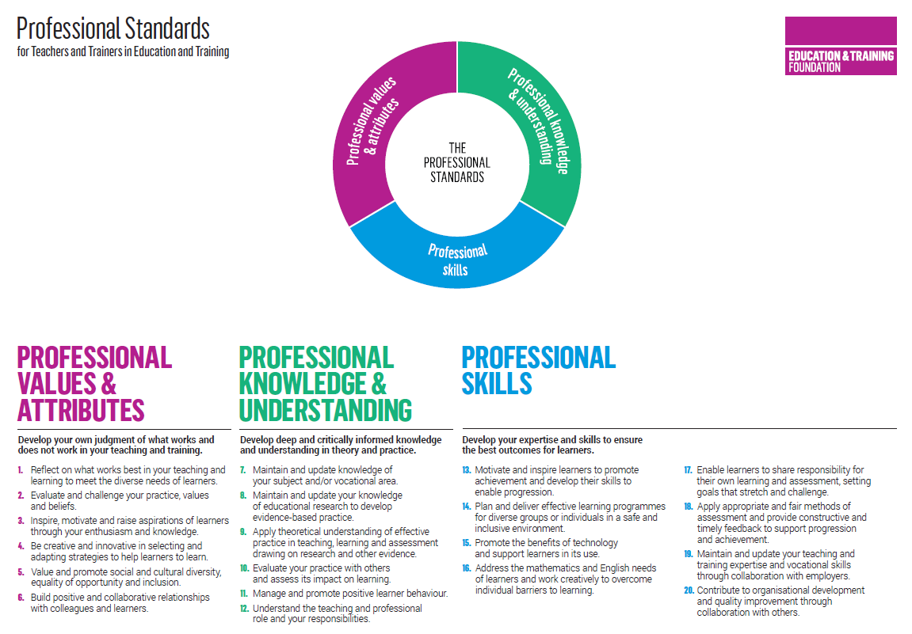

REMEMBER!
If you are in any doubt about the advice to give, please refer your service user to a professional advisor for support

Cheshire West and Chester’s Skills and Employment Service is Matrix accredited which means that the Service has been successfully assessed and awarded a nationally recognised quality kite mark for delivering Information, Advice and Guidance. If you would like further information about the Matrix Standard, visit the website at: www.matrixstandard.com

