**Learning Journey**

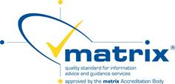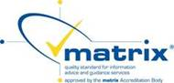We achieved the Matrix Quality Standard for information, advice and guidance in October 2017 and we work to this quality standard to make sure that we provide all learners with advice and guidance which meets their needs and enables them to progress and achieve their goals.

**Stage 3**

Initial assessment of course goals to find your starting point.

**Stage 5**

Feedback from your tutor about your progress. You will receive regular written and/or verbal feedback.

**Stage 6**

Reviewing your achievements.

**Stage 7**

Guidance about moving on to other learning, work, volunteering etc .

**Stage 4**

You will be given an Individual Learning Plan (ILP) to record your progress. Your tutor will also use it to provide written feedback.

**Stage 2**

Initial assessment and induction will form the first part of course and help you identify personal targets.

.

**Stage 1**

Advice, guidance and sign posting. appropriate provision identified. Work Zones offer intro ‘Plan for Success’ course.