BRITISH VALUES - What are they?
British Values |  | Definition | How to promote and apply the values
M | Mutual respect and tolerance | Equality and fairness for all regardless of their background or religious beliefs | - Engage in activities and events such as Black History Month, International Women’s Day, etc  - Have an open minded and liberal attitude to those whose faith and beliefs may defer from your own  - Show respect for an individual’s dignity
I | Individual Liberty | Freedom, for example the right to believe and express oneself in a manner of one’s own choosing within the law | - Make your own decision about the programme you would like to study  - Raise understanding and tackle prejudice so all are treated with respect and in line with the Equality duty  - Promote benefits of diversity  - Celebrate the individuality of your peers and staff
L | The rule of Law | Laws protect everyone, no-one is above the law | - Abide to group rules and the Learner Code of Conduct  - Do not break the law – The laws are put in place to help us live, study and work in a happy, safe and secure environment
D | Democracy | People power - freedom to express opinions and a willingness to listen to other views | - Express your opinion during group discussions and activities  - Have your view on what you think works best for you  - Provide honest feedback about your learning experience

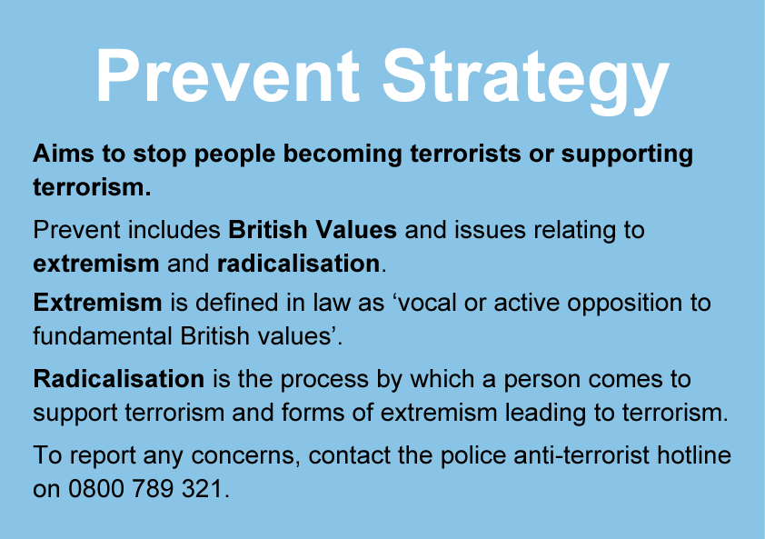
www.gov.uk/ACT

