Guide for Learners - Learning Safely at Cheshire West and Chester Council
2021-22
We are committed to keeping learners and staff safe during the current situation. Our learning centres have been risk assessed and are ‘Covid Secure’ but we need everyone to play their part in keeping them safe.
We expect all learners to respect others and to follow the guidance below:
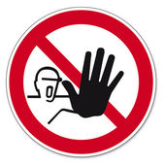 | Do not enter any of our premises if you feel unwell, have a high temperature or any symptoms of cough or cold, however mild
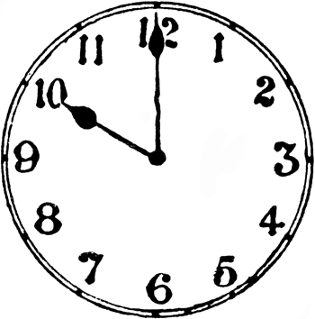 | You must arrive on time for your class. We are staggering start times to minimise congestion in public areas and can only admit you to the centre at your agreed time.
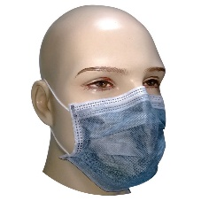 | Facemasks are not required in our classrooms, but are required in Reception, stairways and other public areas. Facemasks will be available if you forget to bring yours. If you are in a high-risk category, you may wish to wear your mask in the classroom.
 | You must wash or sanitise your hands when arriving at the centre and on leaving.
 | You will need to bring your own pens and equipment, as we cannot provide these for you.
 | You will need to bring your own drink as break areas will not be available.
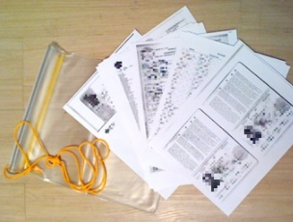 | You will be given a pack with all the course materials and handouts you will need for your course. You must bring this with you to every session.
 | You must respect social distancing markers and guidance in our premises.
Anyone who has been in contact with a person infected with Covid-19 is not permitted on site
CENTRE RULES

Anyone who has flu-like symptoms including fever, a continuous cough or sore throat is not permitted on site

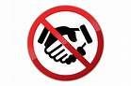
Avoid all physical contact

Wash or disinfect
your hands

Respect social distancing, keep a minimum safe distance of 2m from other people

Cough or sneeze into a tissue and dispose of responsibly, if unavailable use the crease of your elbow

