202Learning Support Funding - Learner Eligibility Form
2022-23

This form provides the auditable evidence that a learner requires additional support on the basis of having a disability and/or learning difficulty, over and above general course support. This additional support is in order to meet a learner’s needs by making reasonable adjustments in line with the Equality Act 2010.

Tutor to complete and submit to Local Authority
Partner Provider: | Project code:
Assessment undertaken by:
Assessor Contact Details: | Telephone: Email:
Date of Assessment:
Learner Details: | Name: DOB:
Course Details: | Title: Start Date: End Date:
Learning Support funding can be claimed for learners that have a learning difficulty or disability to pay for the cost of reasonable adjustments to the classroom or learning programme. Examples of reasonable adjustments could include extra help in the classroom or additional resources in the classroom such as specific software/screen eg to support visual impairment.
Learning Support Needs identified at Initial Assessment were as follows:
Please identify the category that best matches the learner's disability or learning difficulty:
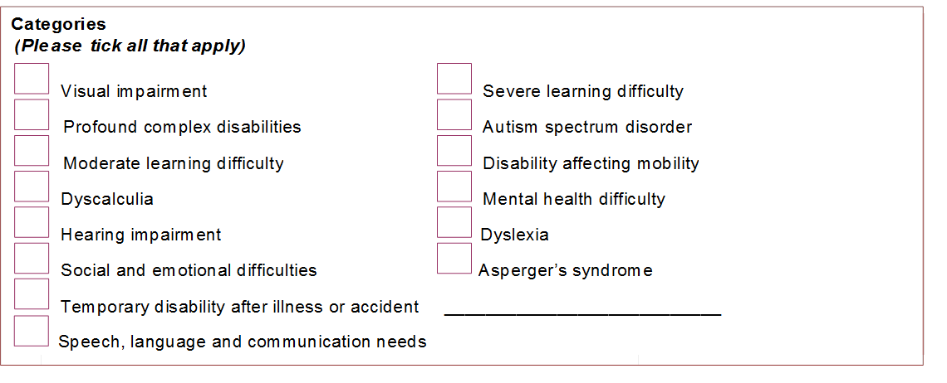

Other (
Please tick all that apply and specify:

Other physical disability __________
_

Oth
er specific learning difficulty
__________

Other learning difficulty

__________

Other disability

__________

Other medical condition ___________
_

What reasonable adjustment do you need to make - tick as many as apply
The learner would benefit from:

Extra tutor support over and above that towards the main delivery aim
Learning assistant/mentor support
Adaptive resources/technology
Deafness support eg Signer
Other . . . (please specify below)

I confirm that the learner named above has been assessed for learning support needs that are over and above ‘everyday difficulties not associated with the learner’s learning on their programme’. This is learning support that is over and above that provided in a standard learning programme which leads to their primary learning goal. I will immediately inform the Local Authority Adult Education team if this support is no longer required at any point during the duration of this course.

Tutor signature: | Date
Please include a detailed breakdown of funding required to support the learner named overleaf:
NB You will required to provide evidence of spend when invoicing the council.
Total: £

Contract Manager signature: | Date
CW&C Skills & Employment - Admin use only:
Amount claimed via ILR/Claim system: Date from: Date to:

Name of the LA approver: Signature:

Role:

