

**The safeguarding of vulnerable adults and children is the responsibility of everyone in CWaC. Please note the information below, and be part of the solution.**

**Definitions:**

**Children** – Age up to 19

**Vulnerable Adult** – aged 19 +

‘Who is or may be in need of community services by reason of mental or other disability, age or illness; and who is or may be unable to take care of him or herself against significant harm or exploitation.’

**If someone disclosures information of abuse:**

**DO:**

* Stay calm and try not to show shock
* Listen carefully rather than question directly
* Be sympathetic
* Re-assure the person that:
* They were right to tell you
* You are treating the information seriously
* You have to inform the appropriate manager

**DO NOT:**

* Press the person for more information other than what you need to make the initial report
* Stop someone who is freely recalling significant events. Will they tell you again?
* Promise to keep secrets. Information will be passed on a need to know basis only
* Make promises you cannot keep (e.g. this will not happen to you again)
* Contact the alleged abuser
* Be judgemental (e.g. why didn’t you run away?)

**Abuse is a violation of an individual’s human and civil rights by any other person or persons.**

There are a variety of forms that abuse can take:

* Physical abuse
* Neglect eg causing harm by failing to meet a person’s care needs
* Sexual abuse eg involvement in any sexual activity against his/her will
* Emotional/psychological abuse
* Financial abuse
* Discriminatory abuse
* Institutional abuse

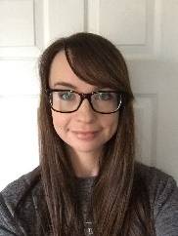

**Ben Watts – Designated Safeguarding Officer**

**Mobile:** 07881 500 226

**Email:**

[benjamin.watts@cheshirewestandchester.gov](mailto:benjamin.watts@cheshirewestandchester.gov)

**Jodie Ronan – Designated Safeguarding Officer**

**Mobile:** 07768 558 858

**Email:** [jodie.ronan@cheshirewestandchester.gov.uk](mailto:jodie.ronan@cheshirewestandchester.gov.uk)

**If you need to report a disclosure, contact:**



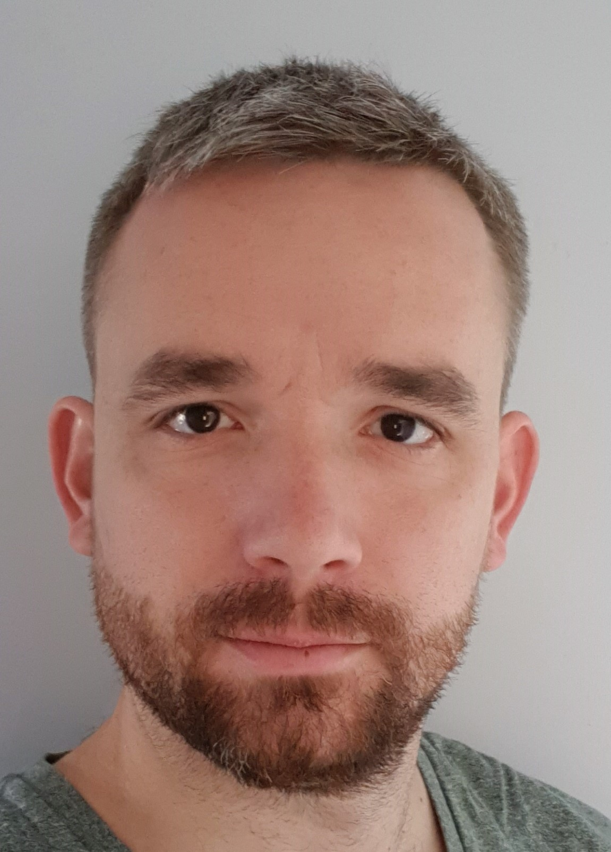

If any of our service users makes a disclosure of harm, **regardless of whether you consider them to be vulnerable or not**, use the S&E Disclosure Report proforma and submit it to one of the S&E Safeguarding Officers – form found at:

**https://cheshireadultlearning.org/**

**REMEMBER – YOU DO NOT NEED PROOF TO REPORT. JUST REPORT!**

**PREVENT** Disclosures involving extremism will be reported to our Local Adult Safeguarding Board or the specialist Cheshire Prevent team. If there is an immediate danger then the police will be called.

The Cheshire PREVENT Team can be contacted on 01606 362 121 or emailed at [prevent@cheshire.pnn.police.uk](mailto:prevent@cheshire.pnn.police.uk)

For advice on radicalisation, the Local Adult Safeguarding Board can be contacted on: