TUTOR COURSE PAPERWORK GUIDANCE 2023/2024
This guidance covers the completion of the following course related paperwork:
- Course Notification
- Scheme of Work – Accredited and Community Learning
- Risk Assessment
- Course Register
- Standard ILP – Accredited and Community Learning
- Course Feedback Form – Accredited and Community Learning
- Tutor Course Review
All paperwork is stored on the Cheshire West Portal: Provider Resources – Cheshire West and Chester (cheshireadultlearning.org)

COURSE NOTIFICATION (not applicable to S&E Direct Delivery Team)
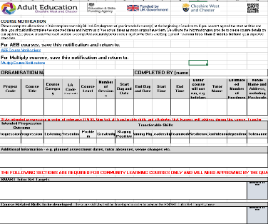
This is a mandatory requirement. Providers must return this notification to the appropriate Skills & Employment Team members a minimum of 2 weeks in advance of the course starting.

Notifications, other than those relating to Multiply, are to be returned to: Amta Xhetani, Vicky Davis and Bethan Colburn
Multiply related notifications are to be returned by to: Simon Dutton and Bethan Colburn
Organisation Name: as it appears on the contract.
Completed By (name and email): the name and email address of the person completing the notification should there be any questions relating to the information provided.
Project Code: this has been provided in the offer letter/contract.
Course Title: exactly as it is to be registered.
Course Category: specify whether the course is Community Learning or Accredited.
LA Code: the Learning Aim code is relevant to accredited courses only.
Course Level: what level of learning is this course aimed at, e.g. Entry Level, Level 1, Level 2?
Start Day and Date/End Day and Date: enter the day(s) of the week that the course will run. It is important to make it clear how many sessions per week there will be, for example, some courses run two days a week over several weeks.
Start Time/End Time: provide the precise start and end time of each session.
Dates course will not run: provide dates and reason why the course will not run, e.g. bank holiday
Tutor Name: this is the name of the tutor running the course. The tutor must be approved by Skills and Employment. Contact the Quality Team to request tutor approval.
Estimated Number of Enrolments: how many learners are expected to enrol on this course? Refer to the contract for targets.
Intended Progression Outcome: where is it anticipated that learners will progress to next, e.g. employment, volunteering, another course? Ensure these are listed in order of relevance.
Transferable Skills: It is not expected that all transferable skills and attributes will be covered on every course. However, those that are must be indicated and this information transferred to the planning documents and ILP.
The transferable skills and attributes are:

Skills
Listening | Receiving, retaining and processing of information and ideas |  | Staying Positive | The ability to use tactics and strategies to overcome setbacks and achieve goals
Speaking/Presenting | Oral transmission of information or ideas |  | Aiming High | Setting clear, tangible goals and devising a robust route to achieving them
Problem Solving | Ability to find a solution to a situation or challenge |  | Leadership | Supporting, encouraging and developing other to achieve a shared goal
Creativity | Use of imagination and the generation of new ideas |  | Teamwork | Working cooperatively with others towards achieving a shared goal

Attributes
Resilience | The capacity to recover quickly from difficulties and toughness |  | Independence | Doing things for yourself and making own decisions without help of others
Confidence | Being certain about own abilities, trusting others, plans or the future |  | Tolerance | Accepting behaviour and beliefs different from own
Additional Information: this could include such things as planned assessment dates, planned tutor absences and details of who will be covering the session etc.
Tutor Set SMART Targets: required for Community Learning courses only. Ensure Tutor Set Targets are SMART. Once they have been approved by the Quality Team, transfer these targets to planning documents and ILPs. For guidance on setting SMART Targets, refer to the IAG section on the Portal: Tutor Resources – Cheshire West and Chester (cheshireadultlearning.org) or speak to the Quality Team.
Course Related Skills: required for Community Learning courses only. These are skills that the learners will develop to achieve their Tutor Set SMART targets. Ensure these are transferred to planning documents and ILPs.

SCHEME OF WORK
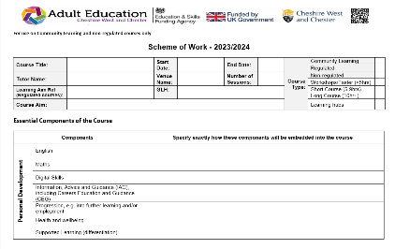
This is a mandatory requirement. There are now separate schemes of work for Community Learning and Accredited courses.
Providers must forward their schemes of work to the Quality Team for approval before the initial course commences, and the completed Scheme of Work only at the end of each course thereafter, unless the standard content changes and requires re-approval during the academic year.

The Scheme of Work is a ‘live’ document that will be updated after each session. It now replaces the need for separate session plans. Going forward, session plans will only be required when a tutor is observed by the Quality Team or an OfSted inspector.
Essential Key Components of the Course: specify, with detail, precisely how each of the key components are embedded into the course, e.g. during induction, posters, handouts, specific activities, discussions etc. Any key skills and attributes that will not be covered on the course can be blanked out, but it must be ensured that they relate to the information provided on the course notification, and to the learners in their ILP.
Group Profile: use this page to record important learner information such as initial assessment results, learner background, needs etc.
Awarding Body Learning Outcomes and Assessment Criteria: Relevant for Accredited courses only. Paste or attach the official awarding body learning outcomes and assessment criteria here.

SMART Tutor Set Targets and Course Related Skills: Relevant for Community Learning courses only. Add the Tutor Set Targets and Course Related Skills in this section. Ensure they match those provided to Skills and Employment in the corresponding course notification.

Breakdown of Sessions: for Community Learning courses, ensure there are SMART session outcomes, and that these are linked to the course related/transferable sills and the tutor set SMART targets. For accredited courses, link SMART session outcomes to the transferable skills and the curriculum reference. The curriculum reference refers to the official learning outcome/assessment criteria number.

FP = feedback provided; FR = feedback response; H = homework set; IR = ILP Review: it is important to plan when learners will be provided with written feedback and homework, as well as time for learners to respond to their feedback and review their ILPs.

Notes and evaluation from this session/planning for next session: record what went well/what may need revisiting, particular support required for individual learners, amendments to plan for next session etc.

INDIVIDUAL LEARNING PLAN (ILP)
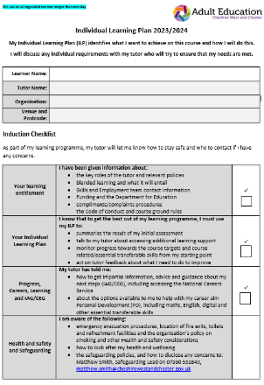
This is a mandatory requirement. There is now a separate ILP for Community Learning and Accredited courses.

ILPs belong to the learner and are used to help them to measure their progress on their course against their course targets, and any personal targets they may wish to set. They can also measure their development of the transferable skills and aptitudes.

The parts of the ILP that are shaded in grey are for the attention of the tutor to either pre-populate before the course starts, or to read through with the learners to ensure understanding.

Induction Checklist: learners must be provided with a full course induction on the first day of the course. Refer learners to the ‘course induction presentation’ and to the learner handbook, both of which are available on the Portal. Learners need to sign the course induction section to confirm that they have received the induction, and that they agree to the code of conduct outlined in the learner handbook.
About My Course: learners must be provided with an outline of the course so that they know what to expect. Cross out/strike through any of the skills and aptitudes that may not be relevant to the course. These will have already been determined and forwarded to the Skills and Employment Team on the course notification.
Subject Area Confidence: learners need to specify how confident they feel about the subject area on the first day of the course, and again at the end.
Summary of Support Needs: based on the pre-course assessment results (maths, English and course specific assessment) learners are required to identify their strengths and highlight the areas they need to work on, or need support with, during the course. Learners will then need to specify how they plan to use the skills and the knowledge they will gain on the course to further their career.
Course Progress Review: For accredited courses only, the tutor must insert the official Awarding Body Assessment Criteria. For Community Learning courses only, the tutor must insert the SMART Tutor Set Targets approved by the Quality Team. These are the same SMART Targets that were forwarded on the course notification. If during discussions with individual learners, individual targets are agreed (i.e. tutor set SMART Targets are made easier or harder as a result of the initial assessment) these should be re-written below the original target in the space marked with an asterisk (*).

Learners must enter their start, mid and end scores against the assessment criteria (for accredited courses) or Tutor Set Targets (for Community Learning courses) at the appropriate stages during the course.

It is essential that tutors provide learners with specific written feedback on each target. Learners need to respond to the feedback and comment on own progress.

If learners wish, they can set SMART Personal Targets. They may need tutor’s help to make the target SMART. At the beginning and during the course, they need to score their progress against any personal targets they set.

Skills and Aptitudes Progress: at the end of the course, learners must tick to confirm the transferable skills and attributes they have developed, and state how they have applied them. If they are attending a Community Learning course, learners are also required to indicate which of the Course Related Skills they have achieved.
Learners must confirm what additional support, if any, they received whilst on the course and state how it helped them.
Career Aim: learners must specify whether they feel they have made progress towards their career aim, and if they would like further advice regarding this and/or help identifying options for the future. The Tutor is required to complete the section that follows as appropriate.

RISK ASSESSMENT
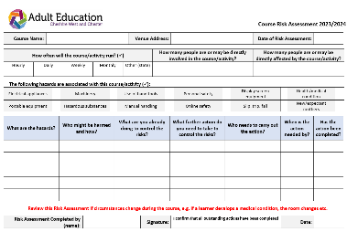
This is a mandatory requirement. All courses must have a risk assessment. Risk assessments must be specific to each course and reflect the current cohort.

This is a ‘live’ document and may change during the course, e.g. if the venue changes, a learner declares an illness etc.

Ensure all sections are fully completed and that the risk assessment is signed and dated. Any actions required to control identified risks must be taken within appropriate timescales. If risks cannot be controlled, or if individual learners cannot be protected, for example, then the activities should not take place.

How often will the course/activity run (): Tick to show the frequency of the sessions, e.g. if the course runs from Monday to Friday in one week, then tick ‘Daily’.

How many people are or may be directly involved in the course/activity?: this is referring to everyone involved in the course including the tutor, learners and any support workers/volunteers.
How many people are or may be directly affected by the course/activity?: as well as those directly involved in the course, this also extends to, for example, other people in the room/vicinity, or those otherwise affected such as family members/other acquaintances.

The following hazards are associated with this course/activity (): consider each of these in turn and tick those that apply. Each hazard that is identified must be recorded, assessed, and appropriate control measures must be identified and actioned.

COURSE REGISTER
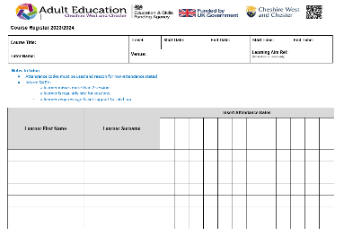
This is a mandatory requirement. The register must be completed for each course and updated at the beginning of each session.

Maintain confidentiality. Learners MUST NOT complete the register themselves.

Ensure attendance codes are used and reason for non-attendance stated.

If required, complete the Attendance Notes section specifying reason for lateness/non-attendance and actions taken (if any).

Inform the Quality Team of the following at the earliest opportunity:

- if a learner misses more than 2 sessions
- if a learner is regularly late for sessions
- if learner requires significant support to catch up, whether that is from missing sessions or not

LEARNER FEEDBACK FORM
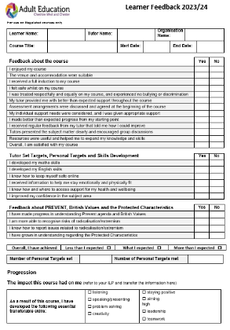
This is a mandatory requirement. There is a different Learner Feedback form for Community Learning and Accredited courses.

All learners are to complete each section of the learner feedback form as independently as possible, but the tutor may explain areas where necessary.

We expect a 100% return of the feedback forms at the end of the course.

If learners wish to complete the feedback form electronically, they can be provided with a QR code that will enable them to provide their feedback on an online form. Speak to the Quality Team if this facility would benefit particular learners.

Ensure learners refer to their ILP to help them to complete the sections on Tutor Set/Personal Targets and the transferable skills and aptitudes. For Community Learning courses, learners must achieve ALL their Course Related and Personal Targets to achieve the course.

TUTOR COURSE REVIEW
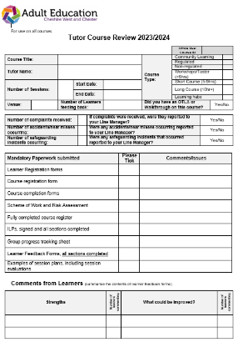
This is a mandatory requirement. All sections must be completed.

If, during the course, there has been a complaint, any accidents, or safeguarding incidents, these must be highlighted on this tutor course review.

The mandatory paperwork section lists all the paperwork that needs to be returned to the Skills and Employment Team. Tick to confirm that these have been submitted and record any relevant comments/state any issues associated with them. If there are any concerns about outstanding paperwork or un-reported incidents, speak to the Quality Team by matter of urgency.

It is essential that all safeguarding incidents are reported to the Skills and Employment Safeguarding Officers, Matthew Smith, Ben Watts or Jodie Ronan at the earliest opportunity.

Comments from Learners: refer to the learner feedback forms to summarise the strengths and areas for improvement as stated by the learners. State how many of the learners returned similar comments, and any actions required in relation to them.
Tutor Evaluation: evaluate the feedback received. Did the learners like the venue? Did they feel supported? Had they developed their transferable skills etc? What is the tutor’s opinion regarding the feedback received? Include evidence that agrees or disagrees with the learner feedback received.

Tutor Reflection: Some examples of what could be reflected on could include, course goals - were they met? Did the learners achieve their targets? Were the handouts useful? What could be done differently next time? What worked well? Are there any areas of good practice that could be shared with others?

Provider Comment: this is for the attention of the contract manager and gives them the opportunity to comment on the feedback received from the learners, and the tutor evaluation/reflection. The contract manager may also wish to highlight any areas for the attention of the Skills and Employment Team.

SKILLS AND EMPLOYMENT CONTACTS
The following are a list of Skills and Employment contacts who may be able to assist with any queries relating to provision:
Senior Management Team
Matthew Smith | Skills and Employment Manager  Safeguarding Lead | 07990 532840  matthew.smith@cheshirewestandchester.gov.uk
Ben Watts | Senior Officer – Commissioning, Performance and Quality  Deputy Safeguarding Officer | 07881 500226  benjamin.watts@cheshirewestandchester.gov.uk
Jodie Ronan | Senior Officer – Curriculum Development and Delivery  Deputy Safeguarding Officer | jodie.ronan@chesirewestandchester.gov.uk
Alison Reid | Senior Officer - Work Zones | alison.reid@cheshirewestandchester.gov.uk
James Holden | Senior Officer – Employment Support | james.holden@cheshirewestandchester.gov.uk

Commissioning, Performance and Quality (Ben Watts)
Amta Xhetani | Partnership, Quality and Curriculum Officer | amta.xhetani@cheshirewestandchester.gov.uk
Vicky Davis | Partnership, Quality and Curriculum Officer | vicky.davis@cheshirewestandchester.gov.uk
Gareth Dudley | Lead Contracting and Financial Performance Officer | gareth.dudley@cheshirewestandchester.gov.uk
Amy Holden | Contracts and Finance Officer | amy.holden@cheshirewestandchester.gov.uk
Adam Yoxhall | Performance Monitoring Officer | adam.yoxhall2@cheshirewestandchester.gov.uk
Olivia Arnold | Learner Data and Research Assistant | olivia.arnold@cheshirewestandchester.gov.uk

Multiply (Jodie Ronan)
Sam Jones | Numeracy Curriculum Lead | samuel.jones@cheshirewestandchester.gov.uk
Simon Dutton | Multiply Project Co-ordinator and Commissioning Officer | simon.dutton@cheshirewestandchester.gov.uk
Bethan Colburn | Curriculum and Quality Support Officer | bethan.coburn@cheshirewestandchester.gov.uk

Work Zones (Alison Reid)
Steve Smith | Winsford and Northwich Work Zones Coordinator | stephen.smith@cheshirewestandchester.gov.uk
Jo Talbot | Chester Work Zone Coordinator | Jo.talbot@cheshirewestandchester.gov.uk
Lewis Belfield | Ellesmere Port Work Zone Coordinator | lewis.belfield@cheshirewestandchester.gov.uk

