
Quality Assurance and Improvement Framework
Policy Statement 2023-24

Scope

This framework covers all funded Adult Learning provision, delivered internally by Cheshire West & Chester Council’s Skills and Employment team and externally by our contracted providers. It explains the monitoring and support arrangements used to ensure the quality of delivery and aligns with other quality monitoring frameworks including the Education Inspection Framework (EIF: (May 2019) www.ofsted.gov.uk. And addresses the Professional Standards for Teachers and Trainers in Education and Training (May 2014) Professional Standards

Continuous Improvement

Our approach to quality aims to support providers to deliver a learning programme in keeping with our intent to enables all our adult learners to progress in life and work.

Based on this framework of support, we expect providers to offer our learners the highest possible quality learning experience and to continuously improve their offer so that learners maximise opportunities to progress in life and work.

Aim of the Framework

This framework provides the criteria against which the Cheshire West and Chester Skills and Employment team monitor the quality and development of their Adult Learning provision. The framework includes the current Education Inspection Framework (EIF) criteria: -
- Quality of Education
- Intent
- Implementation
- Impact
- Behaviour and attitudes
- Personal Development
- Leadership and Management

together with our current priority areas for improvement. Provision is continuously monitored, reviewed, and improved in line with our Quality Improvement Cycle (see below) and progress regularly updated and recorded in our Quality Improvement Plan (QIP) Outcomes from the QIP are used to inform our annual Self-Assessment Report (SAR)

See pages 8-10 of this document for full QA framework criteria

Four principles apply:

- Our partner providers are contractually responsible for delivering a quality learning experience and will have suitable and sufficient quality assurance arrangements in place to support learners.
- The Local Authority will monitor QA arrangements across all provision, internally and externally delivered, against a range of activities and evidence
- Where QA arrangements are not sufficient, we will provide the support necessary to raise standards.
- We will promote continuous improvement in our partners through support and challenge, as appropriate.

Tools to help us monitor quality and support continuous improvement:

- Contractual requirements
- Observation of practice
- Feedback from learners and stakeholders
- Quality groups and other face to face support
- Audit and document review
- Data monitoring and analysis
- Self Assessment

To support our intent to enable learners to progress in life and work, our framework provides:

- Clear requirements for quality assurance and improvement laid out in the contract.
- Rigorous analysis of learning data to measure performance, set targets and strategic direction.
- Utilising a range of feedback opportunities for learners and partners so we can evaluate the service we provide.
- Addressing our SAR development priorities through regular monitoring of the Quality Improvement Plan (QIP).
- Assessment of our strengths and weaknesses and producing an annual self-assessment report (SAR).
- Production of a plan that sets our strategic direction and focuses on maintaining our strengths and addressing our weaknesses that is regularly monitored and updated.
- Partners self - assessment of their own provision
- Maintaining a framework of quality support visits (QSVs)to develop our partners’ capacity to deliver learning and raise standards consistently.
- Carrying out regular themed learning walks and observations of teaching learning and assessment as well as moderation of sampled observations carried out by partners.
- Carry out in depth partner observations looking the full service that a subcontracted partner or direct delivery provides.
- Sharing best practice across the area so that all providers and learners can benefit from consistently high standards.
- Benchmarking our performance and standards through comparison with other Adult and Community Learning provision.
- Continuously reviewing our procedures and policies to ensure best practice.
- Maintaining a database of tutor qualifications and setting an annual target for improvement in the acquisition of appropriate teaching qualifications.
- Implementing staff development both internally to meet key priorities and externally for our partners to ensure standards are driven up on a consistent basis including health and safety and equality of opportunity and diversity.
- Complying with local and statutory requirements eg ESFA, Ofsted, HSE etc

How the Quality Assurance and Improvement Framework Works
As we are working with a diverse range of partners who are each at different stages of development and each with different needs, we do not impose our own procedures on all providers. For example, a proportion of our provision may be sub-contracted to colleges who each will have their own rigorous and well-developed QA systems. For these partners, we ensure that these systems are applied consistently to CW&C funded provision and that there is compliance with our QA procedures.
Many of our other partners are smaller community and voluntary organisations who may be in the very early stages of developing their own systems. We will provide them with appropriate QA proforma and other key resources to support all aspects of learning that they can adapt to meet their own needs whilst ensuring a basic consistency of approach across all our partners.
This Quality Assurance and Improvement Framework is therefore applied flexibly according to need of both partners who have their own fully established and recognised systems and those that need additional support from us to develop their own framework. In practical terms, this means that we:
- Build quality assurance and improvement into contractual arrangements.
- Provide support material for our programmes and explain our basic requirements for managing and quality assuring these learning programmes.
- Monitor the quality assurance arrangements of those partners that have existing and established quality assurance arrangements.
- Monitor and support all partners to ensure that the quality assurance and improvement procedures are being applied consistently across all adult and community learning provision.

Management Information, Data Analysis, Benchmarking and Target Setting
We use the TERMS Management Information System and ALDAS (Adult Learning Data Analysis System) to electronically manage and analyse our data. We can carry out in-depth analysis on our learner and provider data enabling us to passively benchmark our performance nationally and actively benchmark performance against our own past performance and against our in-depth knowledge of ‘what outstanding performance looks like’ for individual curriculum areas. This process of turning data into knowledge informs the strategic direction for the Service. We analyse our provision at local level and provider level enabling us to manage and steer the curriculum to meet both service, regional and national priorities. Analysis is shared with partners at Quality Support Visits (QSVs), contract monitoring visits and Provider events. Analysis is carried out regarding:
- Learners and enrolments
- Area of Learning enrolments per locality/provider
- Intended impact of the provision e.g. employment outcome
- Retention rates
- Gender breakdown
- Age breakdown
- Ethnicity
- IMD Priority areas based on the address of learners
- Employment status of learners
- Rurality of learners
- Pass rate
- Progression
- Teaching qualifications of tutors

Quality Support Visits
The whole team is involved in a range of support visits to partners. Each learning provider partner has a named officer responsible for managing the individual contract and providing support and development as required. Action Plans are developed for emerging providers to encourage best practice from the start of the contract.
Themed Learning Walks
Walkthrough observations will be focussed on specific areas of provision, such as embedded English and maths, prevent, subject specific language, etc. Each month, an area will be observed, with this being shared with partners in advance. The walkthrough observation will only look at this area, to get a broad understanding of how effective that area is across all our providers.
The outcome of these observations will feed into partner and tutor feedback and training. If it is felt that the observed topic is not sufficient, we will seek to do partner training, or work with specific partners where necessary.
We are also introducing nine areas of teaching and learning that should be embedded into every lesson to ensure high quality delivery. During walkthroughs, in addition to a focus area, we will note which of these nine techniques have been seen.
Tutors can expect to have learning walks regularly, at least every two months but more frequently where able..
Observations of Quality of education
Observations enable us to make judgements regarding the effectiveness of our providers’ QA processes in part, by measuring teaching and learning against the Education Inspection Framework. These provide an objective overview which can be used to further enhance and disseminate existing good practice and address recurrent areas for development across our partner providers. The emphasis is on monitoring the quality of education and gaining a perspective of the learners’ experience within the class.
When planning our schedule of class visits, we prioritise providers according to the following selection criteria:
- New partner providers.
- Small providers who do not have the in-house capacity to carry out many class observations.
- Establishing consistency of provision/level of provision across providers.
- New courses.
- Courses where learner feedback/complaints give cause for concern.
- Courses where retention/achievement give cause for concern.
- Specific themes that vary year on year e.g. focus on the promotion of maths and English within the curriculum.

Moderation of Observations of Teaching, Learning and Assessment
OTLAs will continue to monitor and provide formative feedback for our individual tutors. Tutors will be given two working days’ notice of an observation (considering working hours) and will receive a full observation following the observation form. This will include
- Planning
- Personal development
- Behaviour and attitudes
- Teaching and learning
- Assessment for learning
- Learner feedback
- Safeguarding
Following an OTLA, the tutor will be given written feedback, including smart targets for improvement.
The OTLA framework will focus exclusively on matters that the tutor has control over, and the session being observed. Areas that are based more broadly in the provider will be assessed as a part of the provider observations.

Partner Observations
To prepare partners for potential deep dives, we will establish a new “partner observation”. This will be a more thorough look at the overall provision that the partner provides, across a range of tutors and courses. It will include, but will not be limited to
- Discussion with individual learners
- Discussion with individual teachers
- Discussion with an individual curriculum leam, head of department or workplace supervisor
- Discussion with a group of learners (induction, assessment, safeguarding, prevent, feedback, learning planning, what they need to bring and prepare for, implementation through the lens of the learner)
- Joint scrutiny with a teacher/assessor of learner’s progress from starting point (progress tracking records
- Discussion with a group of teachers (how is assessment used, how are lessons planned against curriculum)
- Joint work scrutiny with a teacher or manager
- Case study of learners who have high needs
- Visits to learning and work environments
- Discussion with a manager on outcomes (impact)
- Review of accommodation, resources, or workplace
- Discussion with an apprentice
- Discussion regarding safeguarding
We would be hoping that these activities will triangulate to give an overall picture of the provision being delivered. Partners will be given two weeks’ notice to prepare for a partner observation in order to gather the relevant information needed and arrange appropriate dates to allow for the activities mentioned.
Rather than repeat observations, we will conduct a series of OLTA’s in advance of the partner observation, including conversations with tutors and learners, which will feed into the partner observation. This will relieve the pressure on tutors during the observation process.
Work scrutinies will require a sample of learners work from a range of courses and will follow the work scrutiny framework that will be provided. We will be looking to see evidence that the work is consistent, follows the scheme of work, shows evidence of feedback and response, has sufficient challenge, and demonstrates positive attitudes to learning. Supportive guidance and SMART targets will be given based on the scrutiny.
Feedback will be given in line with current Ofsted guidance on quality of education, behaviour and attitudes and personal development. This will allow us to ensure that our provision is consistently good or outstanding across our whole curriculum.
In terms of Quality of education, this means:
- Curriculum intent is strong. Providers and tutors have a clear understanding of the intended curriculum and what it means for their practice
- Implementation is consistent including for those with SEND and high needs.
- There are consistently demanding curriculum goals that match the aims of the curriculum demonstrated by planning and sequencing towards sufficient knowledge and skills for future learning and employment
- Learner work is of constantly high standard
- Learner achievement is consistently high
- Learners are studying the intended curriculum, demonstrated through discussion and work scrutiny
- Teachers have excellent subject knowledge
- Teachers present information clearly, check understanding effectively, identify misconceptions and provide clear and formative feedback
- Work being completed is sufficiently demanding
- Subject specific, technical, or professional vocabulary is embedded in curriculum
- Support staff are utilised effectively
- Techniques and methodology that embeds long term memory is clear throughout the planning and delivery of the courses
- Assessment is used to monitor and guide learning. This can be in terms of subject knowledge, skills, understanding or evaluation
- The learning environment is conducive to effective learning and resources and materials are reflect the ambitions intentions for the courses on offer
- Where used, remote learning is well integrated into the programme of study
- Learners make substantial and sustained progress from their starting points in each of their courses
- Learners are equipped for the next stage of employment
In terms of behaviour and attitudes this means:
- Learners are respectful of one another and staff. They play a part in producing a positive learning environment
- Learners are resilient and persistent in the face of challenge or difficulty
- Learners participate in activities beyond the basic requirements, such as competitions, social action projects, etc.
- Where learners are not consistently demonstrating these attitudes, the provider has taken steps and adjusted to support them in their progression
- Attendance and punctuality are consistently high, including any distance or remote learning activities
- Principles of equality, diversity, tolerance, and respect are nurtured among all learners and staff. Bullying, harassment, discrimination, and intimidation are rare, and dealt with swiftly and appropriately
In terms of personal development this means:
- Personal development is consistently and extensively promoted to all learners. Learners have a wide, rich set of experiences offered to them, that teach them why it is important to contribute actively to society
- Participation in wider activities is high, and those from disadvantaged backgrounds are not hindered in their involvement in them
- Learners are prepared for further education, employment or training by being provided with unbiased potential next steps, high quality locally relevant careers guidance, and opportunities for work experience
- Learners are taught how to protect themselves from radicalisation, are taught fundamental British values, appreciate diversity within society, and how to have respect for various protected characteristics as defined in law
Partners can expect observations at most once every 2 years.

Sharing Best Practice

Provider Network events and ‘Cluster Group’ Meetings are held throughout the academic year. All providers are expected to attend. These opportunities encourage the sharing of good practice and development of referral opportunities which will improve progression pathways for our learners. These events will also provide scope for specific training needs that arise from feedback from the quality assurance process.

Information, Advice and Careers Education Guidance

Skills and Employment are committed to the development of their staff and partners through effective delivery of information, advice and guidance (IAG). We are continually developing our communication channels to ensure we can promote our services and ensure accessibility of information. Feedback on the quality of the service is obtained and acted upon and continuous quality improvement is ensured through monitoring and action. We are Matrix accredited for our IAG to learners and partners. From promotional material to end of course review, impartial IAG is embedded throughout delivery.

Feedback

One of the most effective ways of judging our performance and informing improvement is to listen to our partners, learners and funders. We have established formal channels of communication to ensure we are able to systematically pick up and act upon feedback we receive:

Partner feedback is obtained by:

- Networks, training and development events
- Stakeholder consultations
- Development Officer support visits
- Quality support visits
- Annual review process
- Tutor feedback gathered via teaching and learning observation process
- Partner self-assessment process
- Contributory reviews as part of our self assessment process

Learner feedback is obtained by:

- End course feedback from all learners
- Talking to learners through the teaching and learning observation process
- Receiving compliments and complaints both directly and through contractual obligations with partners
- Promoting opportunities for feedback including national learner surveys

Monitoring of areas for improvements including Safeguarding and Equality and Diversity

Quality systems (qsys) tracks compliance against contractual responsibilities including CPD needs for tutors and DBS compliance. The system tracks improvements highlighted during Observations and ensures these improvements are addressed at support visits. In addition, we monitor that samples of Risk Assessments are of good quality and that observations undertaken reflect the broad range of provision.

The Learning Journey
Each part of the Learning journey is covered by planning tools to enhance the quality of information the learner receives, the support given to make the most of their learning experience and the actual teaching and learning experience itself.

LEARNER JOURNEY (Tutor Version)

Initial Learner Enquiry |  | Guidance on to Appropriate Course
Induction |  | Enrolment
Initial assessment |  | ILP and Goal Setting
Ongoing progress reviews |  | Teaching, Learning & Assessment
Assessment and Evaluation |  | Achievement and Progression to next steps

Policies, Procedures, Guidance and Strategies

The Skills and Employment service operates within a set of policies, procedures and strategies published by Cheshire West & Chester Council. In order to embed these ways of working, we have contextualised a series of policies and guidance which ensure that partners are able to adopt the critical elements within their delivery whilst aligning provision to the policies and procedures of the Council.

The documents that have the most immediate impact on our work include:

- Safeguarding and Disclosure
- The Self-Assessment Report (SAR)
- Quality Improvement Plan (QIP)
- Equality and Inclusion Policy Statement
- Health and Safety Policy Statement
- Assessment Policy Statement
- Achievement in Non-Accredited Learning Policy Statement
- Withdrawal Policy Statement
- Comments, Suggestions and Complaints Policy Statement
- Single Equality and Inclusion Scheme
- Tuition Fee Policy for both Adult Skills Provision and Community Learning
  - Information Security Statement based on the GDPR 2018 and Freedom of Information Act 2005

Financial and Administration procedures

All written policies, procedures and strategies are reviewed on an annual basis to ensure we are up to date with current legislation and best practice and are available on request.

Self Assessment Process and Development Planning

Each year the Local Authority publishes a rigorous Self-assessment Report (SAR) based on an annual QA process that is embodied in the Quality Improvement Plan (QIP) This leads to the production of an informed development strategy for the following year. Self Assessment is based on evidence from:

- Data analysis
- Partner provider performance
- Partner provider self-assessment reviews
- Partner provider contributory reviews to our SAR
- Teaching and Learning observation reports
- Learner Feedback
- Feedback from funding bodies
- Quality Support Visit reports
- National and regional strategy

Quality Assurance Mark (CW&C provision)

Sub-contracted providers meeting the requirements of the Quality Assurance and Improvement Framework will be awarded an annual ‘Quality Assured’ standard. This ‘approved status’ that means that the Local Authority is assured of the level of quality of the provision delivered by that provider.

Adult Education - Quality Assurance and Improvement Framework

Judgements are made against the following standards/ Key Performance Indicators (KPIs) from evidence produced as part of the contractual process:
KPI 1 | CONTRACT PERFORMANCE
1.1 | Contract delivered within agreed delivery hours and enrolment targets (including any in year re-profiled targets)
1.2 | Efficiency and compliance of contract and finance
1.3 | Timeliness of data returns
1.4 | Quality of data returns
1.5 | Completeness of data
1.6 | Communication with the Service, including attendance at meetings/CPD events
1.7 | Overall commitment to quality improvement
1.8 | Timely response to service requests for information (including SAR return)
1.9 | Robust self-assessment processes and action planning for improvement in place

Quality of Education (QIF)
KPI Ref: | Aspect: |  | R | A | G
2.5a | a | Tutor has good knowledge of the subject and course
2.6a | b | Tutor presents subject matter clearly promoting appropriate discussion about the subject matter
2.6b | c | Tutor checks learners’ understanding systematically, identifies misconceptions and provides clear feedback
2.6c | d | Teacher responds and adapts their teaching as necessary
2.7a | e | Teaching is designed to help learners to remember in the long term the content they have been taught
2.7b | f | Teaching is designed to help learners integrate new knowledge into larger concepts
2.8 | g | Assessment is purposeful and necessary to enable learners to embed and use their knowledge, and to inform teaching
2.9a | h | Tutor creates and environment that allows the learner to focus on learning
2.9b | i | Resources reflect the curriculum and are necessary to support the provider’s ambitious intentions
2.9c | j | Resources used build knowledge and skills for future learning and employment
2.10 | k | At early stages of reading, reading materials are closely matched to learners’ phonics knowledge (English courses only)

BEHAVIOUR AND ATTITUDES – EIF
KPI Ref: | Aspect: |  | R | A | G
3.1a | a | There is a high expectation for learners’ behaviour and conduct and there are applied consistently and fairly
3.1b | b | Learners comply with the high expectations for behaviour and conduct
3.2a | c | Learners’ attitudes to their education or training are positive
3.2b | d | Learners are committed to their learning
3.3 | e | Learners have high attendance and are punctual
3.4a | f | Relationships between staff and learners are positive and mutually respectful
3.4b | g | Learners feel safe on their course and do not experience bullying or discrimination

PERSONAL DEVELOPMENT – EIF
KPI Ref: | Aspect: |  | R | A | G
4.1 | a | The curriculum extends and provides for learners’ wider development including their interests and talents
4.2a | b | The curriculum and wider work support the development of character including resilience, confidence, independence and other personal attributes
4.2b | c | Learners know how to keep physically and mentally healthy
4.3 | d | The provider prepares learners for future success in their next steps by providing them with impartial IAG/CEG
4.4a | e | Learners are prepared for life in modern Britain by developing their understanding of PREVENT and British Values
4.4b | f | Learners are supported to understand diversity, and respect for the protected characteristics is promoted

KPI 6 Priorities
KPI Ref: | Aspect: |  | R | A | G
6.1 | a | Tutor clearly plans to meet individual learner needs, and makes reasonable adjustments
6.2 | b | Robust, SMART and challenging goals/targets are negotiated, agreed and monitored enabling learners to make good progress
6.4 | c | Effective and consistent formative and summative assessment is in place
6.6 | d | English, maths and ICT consistently embedded into the course
6.8 | e | Learners receive full induction and know their rights and responsibilities
6.9 | f | Tutors ensure that learners develop appropriate work ready skills, and benefit from appropriate work-related learning
6.10 | g | On-course learner progress is monitored and used effectively to inform planning for individual needs
6.11 | H | Tutor sets demanding targets for skills development

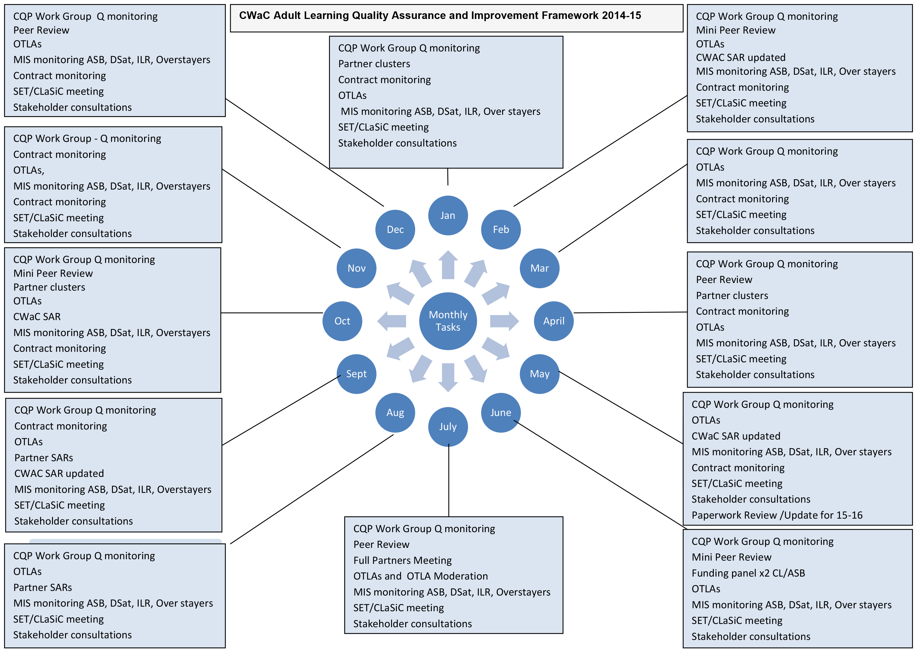
CW&C Skills and Employment QA and Improvement Framework 2015-16

CW&C Skills and Employment QA and Improvement Framework 2023-24

